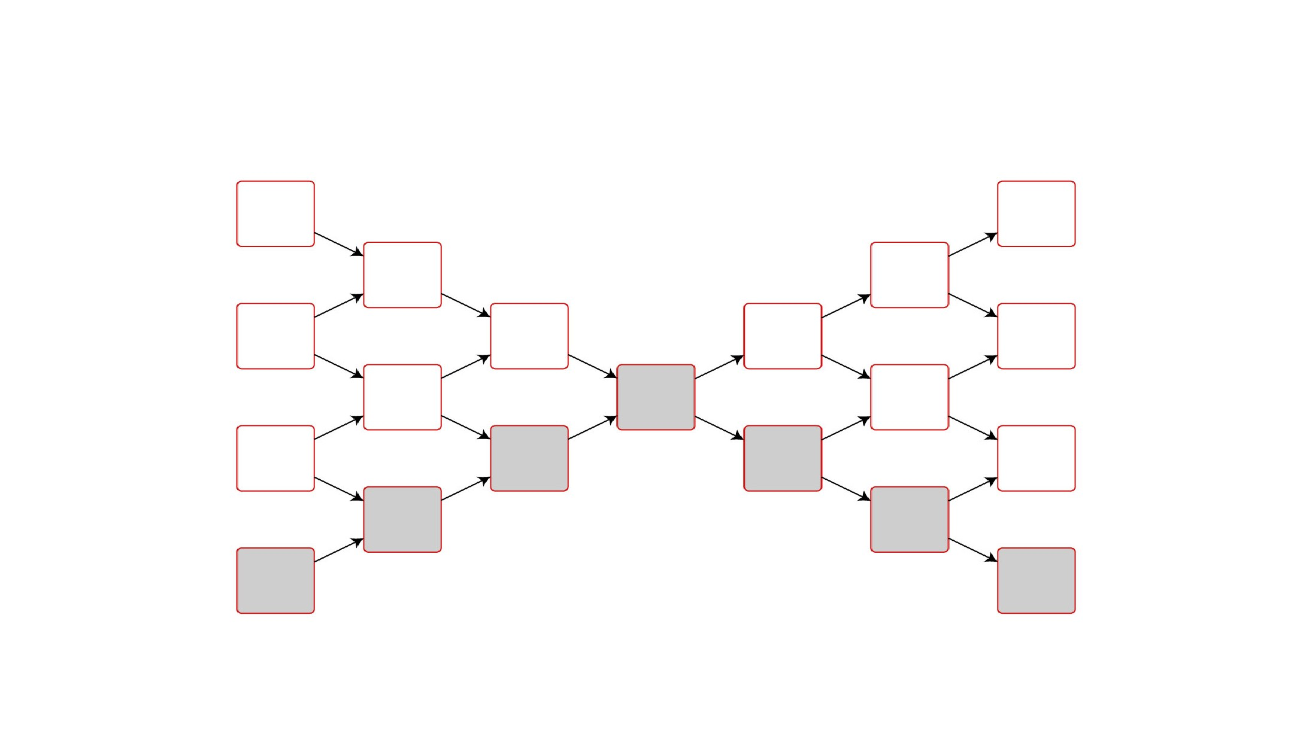

Supply Chain Network Diagram for Desktop Computer

Consumer

Consumer

Consumer

Consumer

Electronics Store

Computer Store

Online Seller

Computer Wholesaler/ Distributor

Electronics Wholesaler/ Distributor

Screen

Circuitry/ Electricals

PCB

Hardware

Monitor/ Keyboard

Desktop Computer

Ore

Steel

Glass

Silica